Task Description #1: Linear Search
Implementation with AI Assistance
Task: Use an AI tool to generate a Python program that implements the Linear Search
algorithm.
Instructions:
Prompt AI to create a function linear_search(arr, target) that searches
for a target element in a list.
Return the index of the target element if found; otherwise, return -1.
Ask AI to include a docstring explaining the best-case, average-case, and
worst-case time complexities.
Test the function with different inputs, including an empty list and a target that
is not present.
Expected Output:
A working Python program implementing Linear Search.
Test cases with outputs.
A brief explanation of time complexity.
PROMPT: Write a simple Python program for Linear Search using linear_search(arr, target). Return the index if found, otherwise return -1. Include a docstring explaining best, average, and worst-case time complexity. Test with normal inputs, an empty list, and a target not present. Show outputs and briefly explain the algorithm.
Include all required test casesMention the one-element test
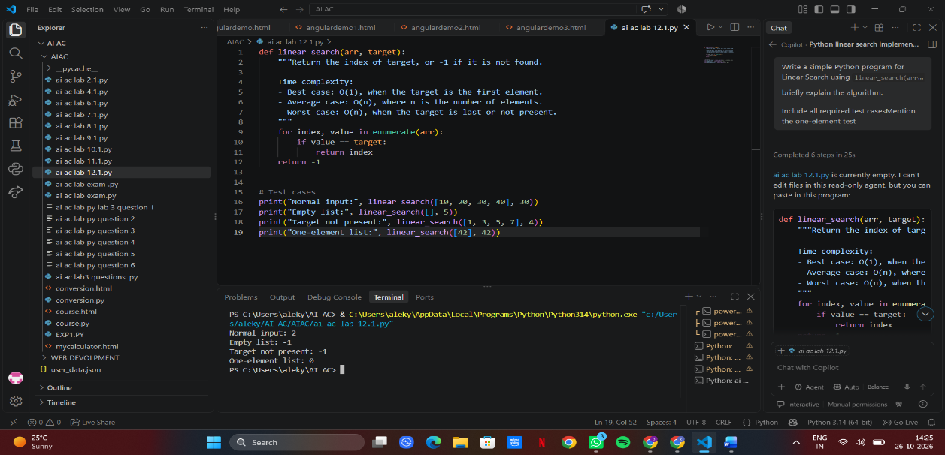
Task Description #2: Binary Search
Implementation with AI Optimization
Task: Use AI to generate an efficient Python program that implements Binary Search
on a sorted list.
Instructions:
Prompt AI to create a function binary_search(arr, target).
Use the iterative approach to find the target element.

Return the index if the element is found; otherwise, return -1.
Ask AI to explain why the input list must be sorted.
Include best-case, average-case, and worst-case time complexities.
Test the program with the first element, last element, middle element, and a
missing element.
Expected Output:
A working Binary Search program.
Test results for different target values.
An explanation of why Binary Search is more efficient than Linear Search for
large, sorted lists.
PROMPT: Write a simple Python program implementing iterative Binary Search using binary_search(arr, target) on a sorted list. Return the index if found, otherwise -1. Explain why the list must be sorted and include best, average, and worst-case time complexities. Test the first, last, middle, and a missing element. Briefly compare Binary Search with Linear Search.
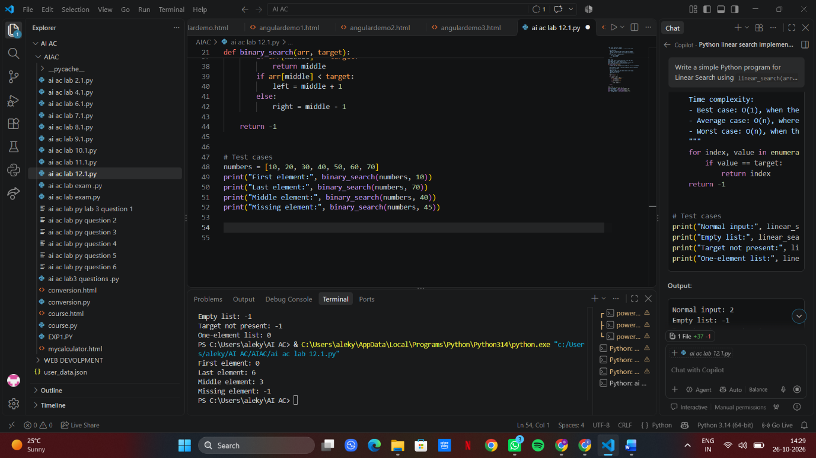

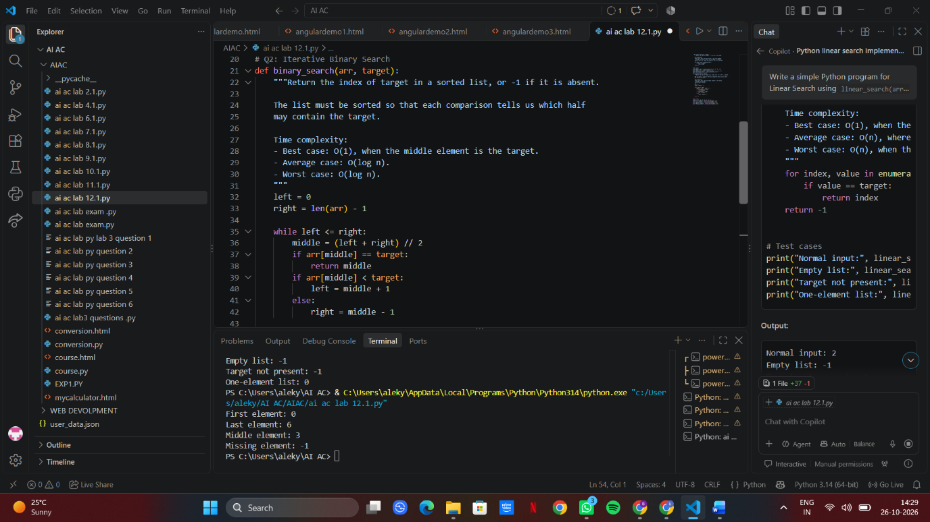

Task Description #3: Student Record Search
System
Scenario: A university maintains student records containing roll numbers, names, and
marks. Faculty members need to search for student records using roll numbers.
Student Task:
Use AI to recommend either Linear Search or Binary Search for searching
student roll numbers.
Implement both algorithms in Python.
Test the algorithms using a list of student roll numbers.
Compare the results when the roll numbers are stored in unsorted and sorted
order.
Explain the time complexity of both algorithms.
Expected Output:
Python functions for Linear Search and Binary Search.
Sample student records and test results.
A comparison table showing algorithm, input requirements, and time
complexity.
Justification for selecting the appropriate search algorithm.
PROMPT: Write a simple Python program for a Student Record Search System using both Linear Search and Binary Search. Search student roll numbers and display the student record. Test with unsorted and sorted roll numbers. Include sample records, test results, a comparison table of input requirements and time complexities, and explain which algorithm is better and why.
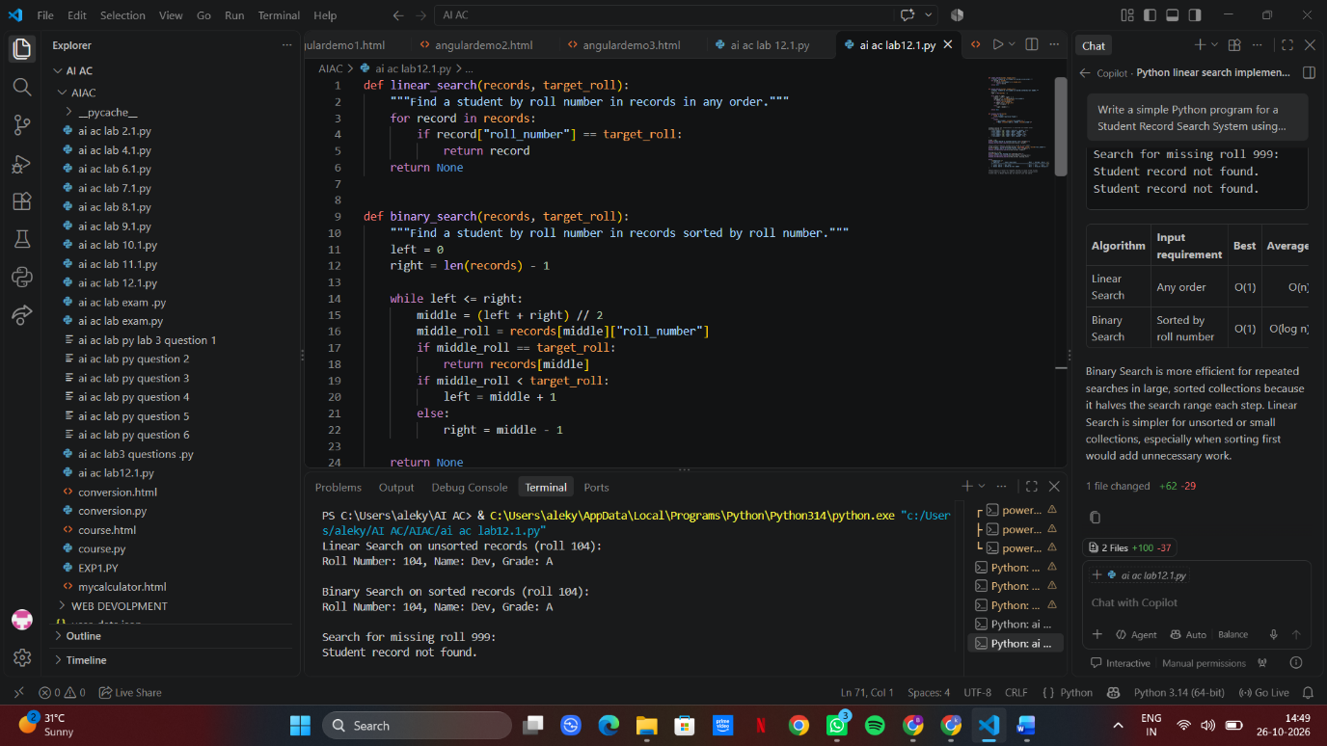

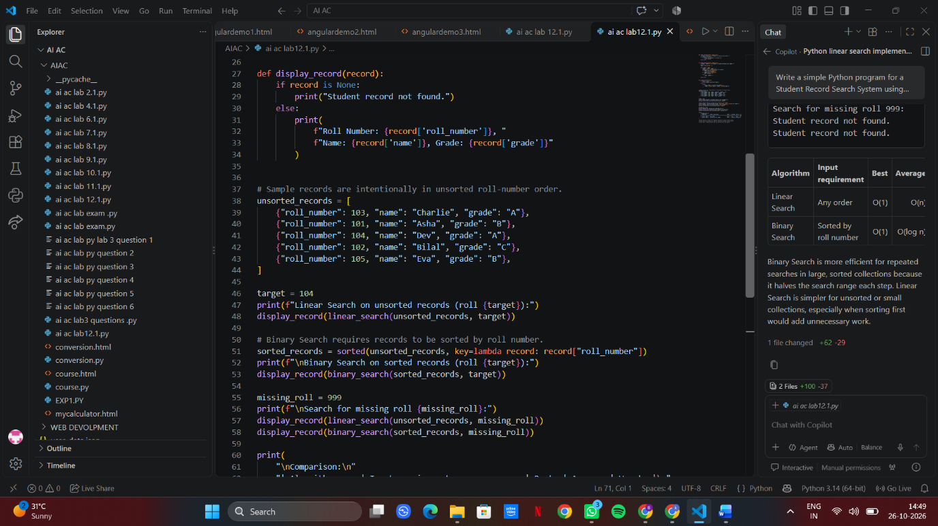

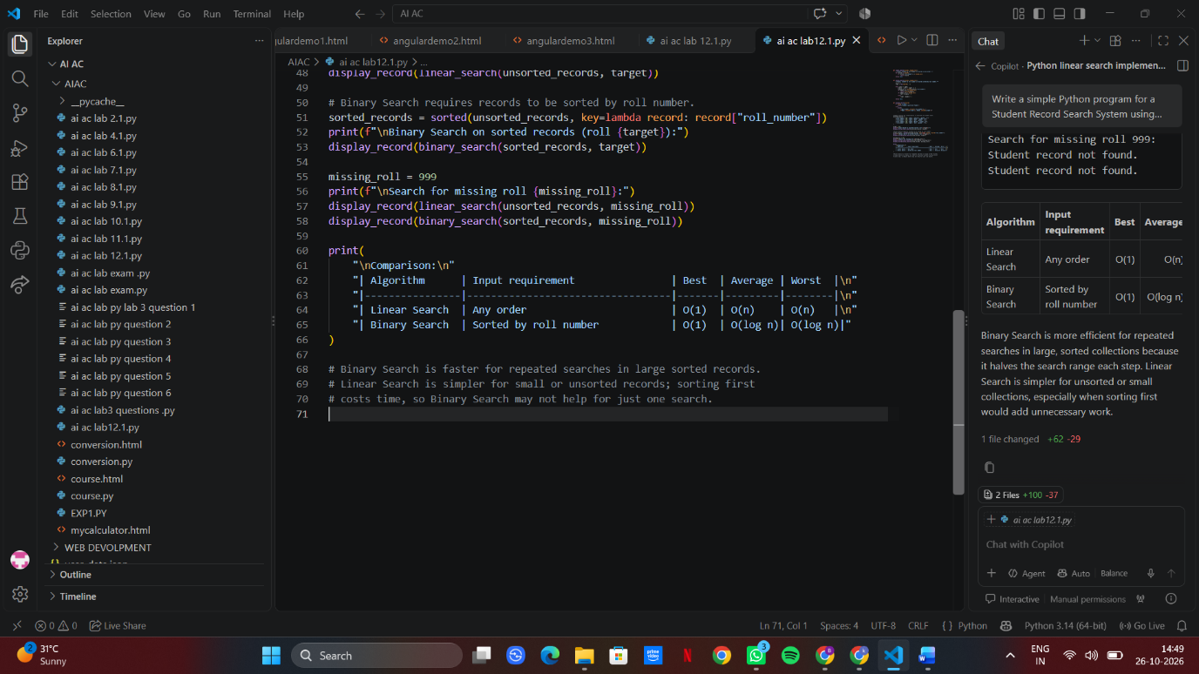

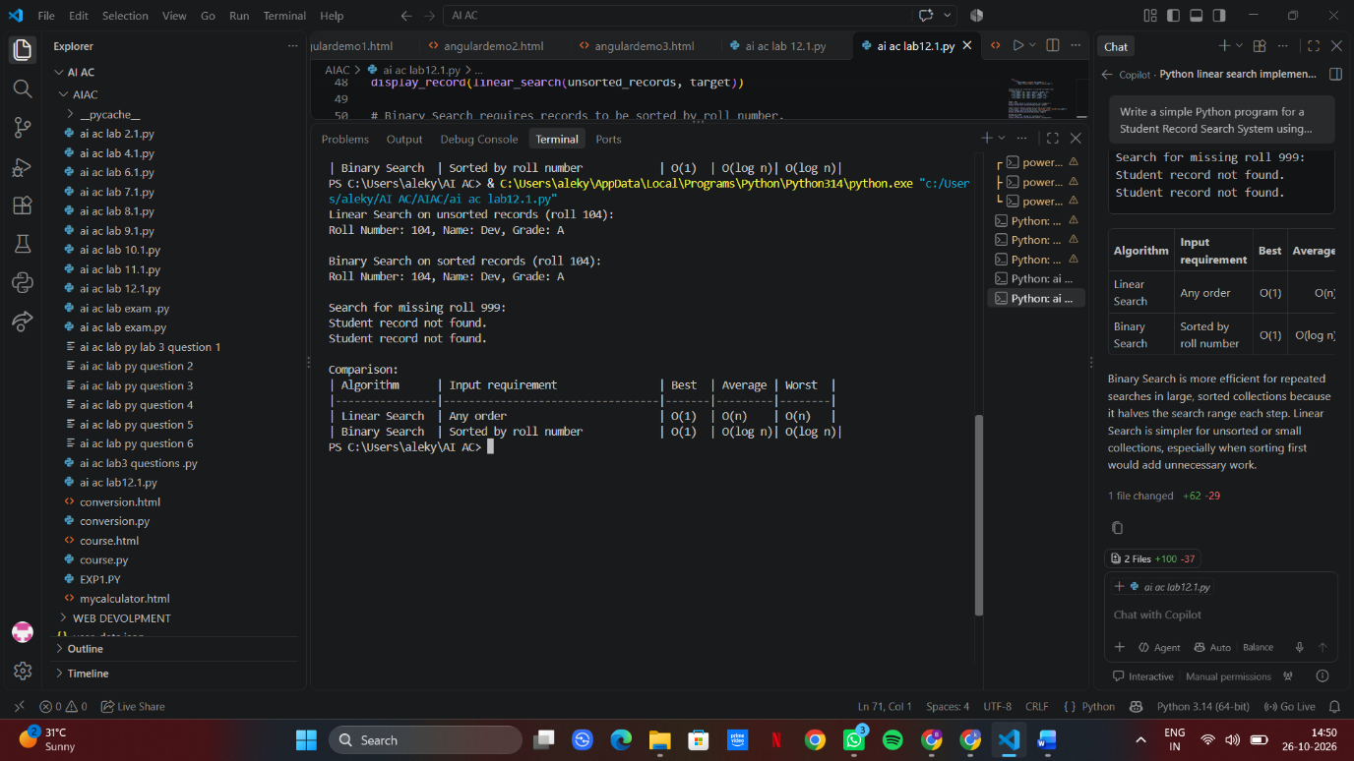
Task Description #4: Library Book Search
System
Scenario: A college library maintains a list of book identification numbers. Students
and librarians need to find books quickly using their book IDs.
Student Task:
Use AI to generate a Python program that searches for a book ID using Linear
Search.
Implement Binary Search to search for the same book ID in a sorted list.
Test both algorithms when the book ID exists and when it does not exist.
Measure and compare the number of comparisons performed by each
algorithm.
Ask AI to explain which algorithm is suitable for a large, sorted collection of
book IDs.
Expected Output:
Working Python programs for both searching algorithms.
Test cases with search results.
A comparison of the number of comparisons performed.
A conclusion explaining the efficiency of each algorithm.
PROMPT: Write a simple Python program for a Library Book Search System using Linear Search and Binary Search. Search for a book ID and return its index or -1 if not found. Count and compare the number of comparisons for both algorithms. Test with existing and missing book IDs. Explain which algorithm is more efficient for a large, sorted collection and why.
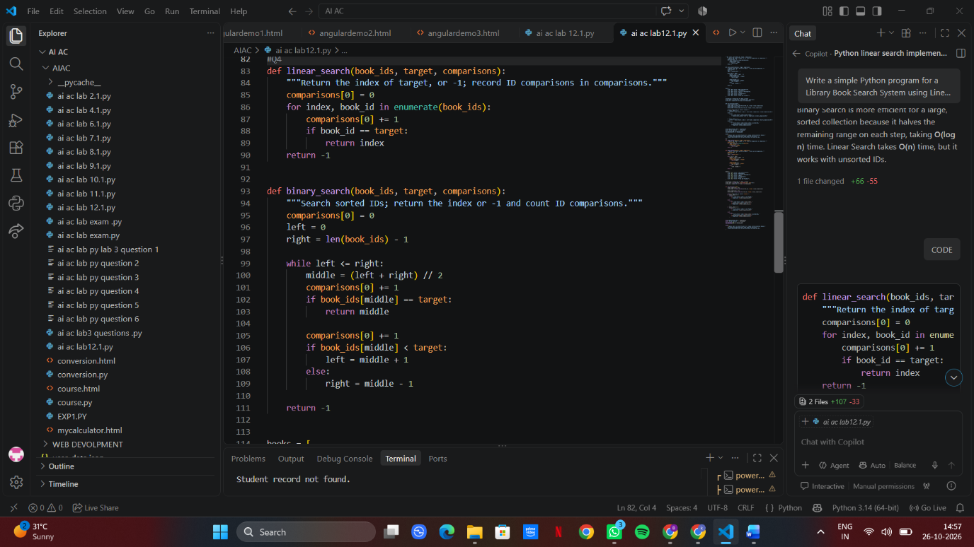

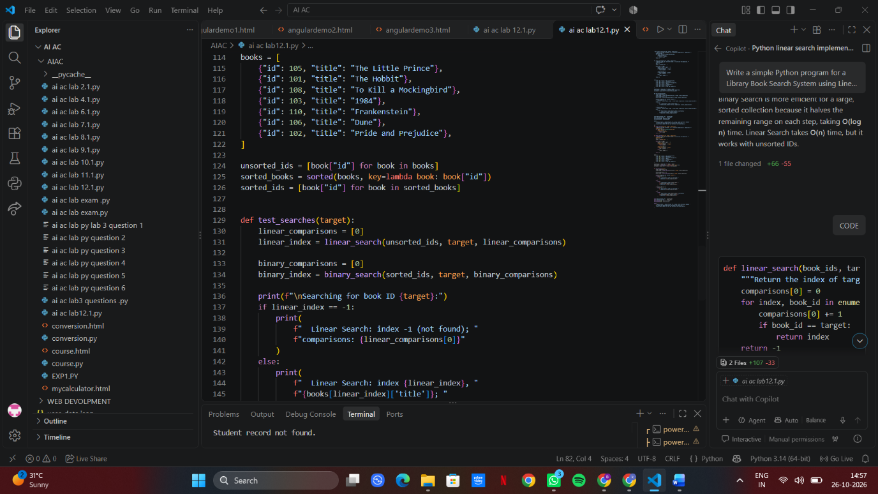

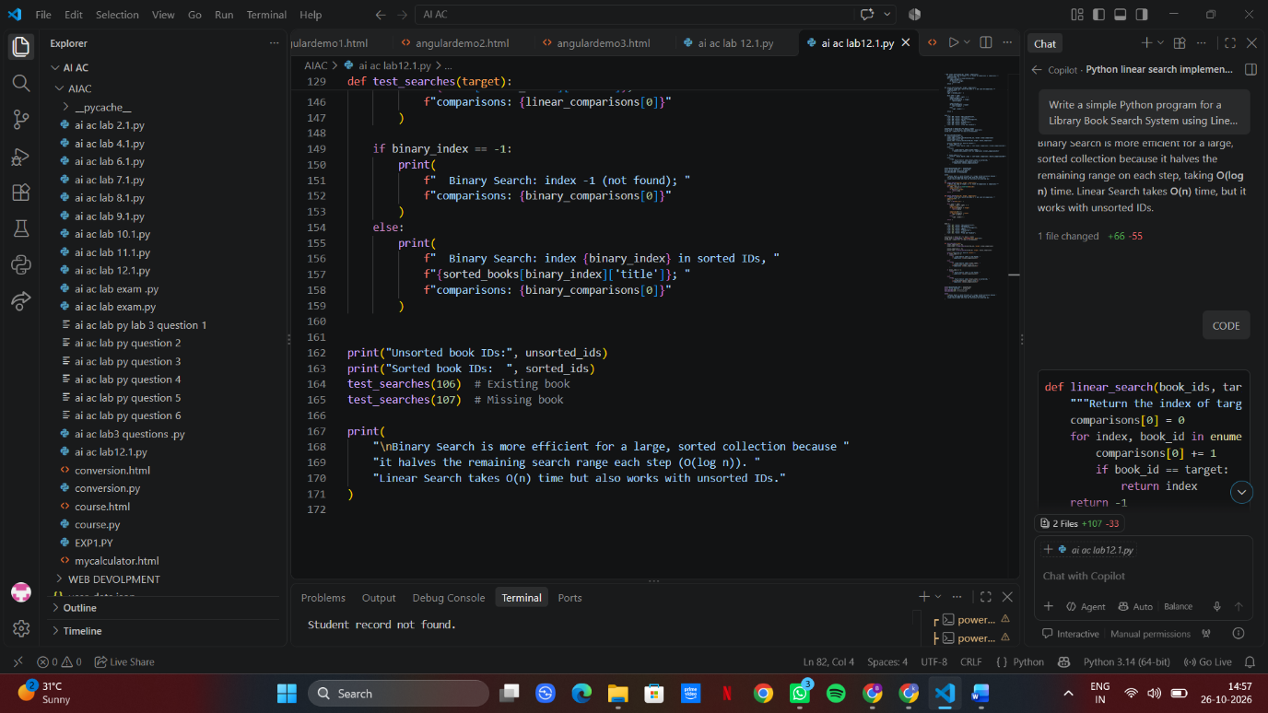

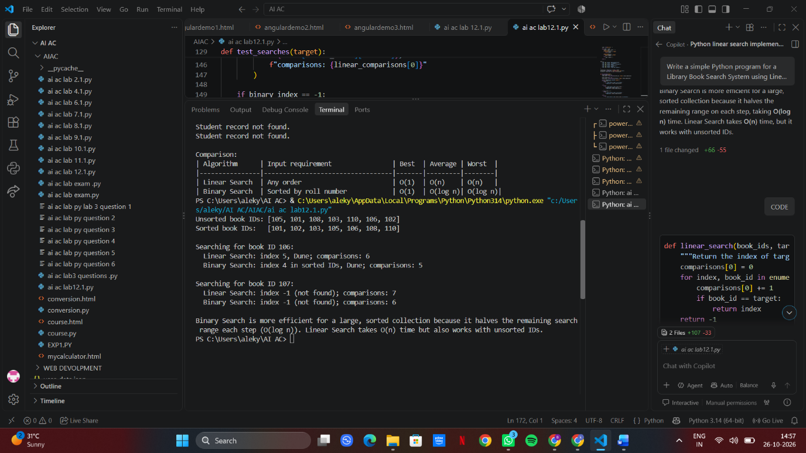

Task Description #5: Searching Algorithm
Comparison and Optimization
Scenario: An online shopping platform maintains product IDs for thousands of
products. The system must locate a product quickly when a customer enters a product
ID.
Student Task:
Use AI to generate Python implementations of Linear Search and Binary
Search.
Test both algorithms using the same collection of product IDs.
Compare the execution time and number of comparisons for different input
sizes.

Test the algorithms with the first element, middle element, last element, and an
element that does not exist.
Ask AI to suggest optimizations and explain the limitations of each algorithm.
Present the results in a table and justify which algorithm is appropriate for
sorted product IDs.
Expected Output:
Python implementations of both algorithms.
Test results for different input sizes.
A comparison table containing execution time, number of comparisons, and time complexity.
A brief conclusion based on the experimental results.
PROMPT: Write a simple Python program implementing Linear Search and Binary Search for product IDs. Test both using the same sorted product ID lists of different sizes. Search for the first, middle, last, and missing elements. Measure execution time and number of comparisons. Present results in a table, explain time complexities, suggest optimizations and limitations, and conclude which algorithm is best for sorted product IDs.


